# Kanban – Leads

The prebuilt *Kanban – Leads* provides an overview of registered leads in your NetSuite account, with each Kanban column representing a lead status. The last two Kanban columns represents leads converted to prospects and records with the status *PROSPECT – Closed Lost* modified within the last month.

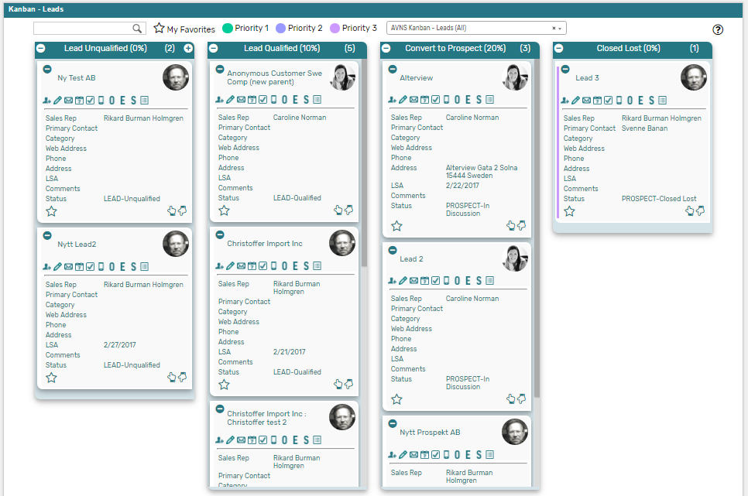

### Kanban – Leads: Prerequisites

Before using the *Kanban – Leads* board, please make sure the prerequisites listed below are fulfilled in order for the board to function as expected.

1. **Customer Status**  
   Since the columns of the prebuilt *Kanban – Leads* board are based on NetSuite standard Customer status, it is important that the statuses presented in the board are available in your NetSuite account.   
     
   Navigate to Setup 🡪 Sales 🡪 Customer Statuses (Administrator) to find the list of Customer Statuses available in your NetSuite account. Compare the list from your NetSuite account with the Customer Status list which the prebuilt *Kanban – Leads* board is based on (picture below).   
     
   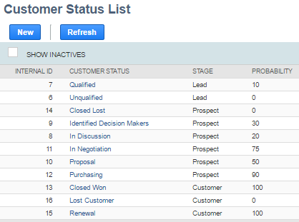  
     
   If the Customer Statuses differ between your NetSuite account and the picture above, you will need to edit the settings of the Kanban Columns for the *Kanban – Leads* board.  
   ***Please refer to the section ‘Kanban Columns’ in the ‘Kanban User Guide’***
2. **Sales Rep & Sales Rep Image**  
   Make sure to mark the checkbox ‘Sales Rep’ on the Employee record for all available Sales Reps.   
   If an image has been uploaded to the *Image* field on the Employee record, this image will be displayed on the Kanban card. If no image is available, a predefined profile icon will be displayed instead.

### 

### Kanban – Leads: Card Moves & Column Actions

The *Kanban – Leads* board contains four Kanban Columns. Each column has been configured with one or several Column Actions. Double clicking on any card in the *Kanban – Leads* board will open the lead record in edit mode.



1. **Lead Unqualified (0%)**
   1. *Card Moves* – Kanban cards in the column *Lead Unqualified (0%)* can be moved to all other columns in the Kanban board.
   2. *Column Actions* – when moving a Kanban card to the column *Lead Unqualified (0%)* the status of the record represented in the Kanban card will be updated to *LEAD* – *Unqualified* and the Sales Rep will be set to *@MySELF@* (Current User).
   3. *Add Card* – it is possible to add a Kanban card (a new record) from the column *Lead Unqualified (0%)* by clicking on the + icon in the top right corner of the column.



1. **Lead Qualified (10%)**
   1. *Card Moves* – Kanban cards in the column *Lead Qualified (10%)* can be moved to all other columns in the Kanban board.
   2. *Column Actions* – when moving a Kanban card to the column *Lead Qualified (10%)* the status of the record represented in the Kanban card will be updated to *LEAD* – *Qualified* and the Sales Rep will be set to *@MySELF@* (Current User).
2. **Convert to Prospect (20%)**
   1. *Card Moves* – Kanban cards in the column *Convert to Prospect (20%)* can be moved to all other columns in the Kanban board.
   2. *Column Actions* – when moving a Kanban card to the column *Convert to Prospect (20%)* the status of the record represented in the Kanban card will be updated to *PROSPECT* – *In Discussion* and the Sales Rep will be set to *@MySELF@* (Current User).
3. **Closed Lost (0%)**
   1. *Card Moves* – Kanban cards in the column *Closed Lost (0%)* can be moved to all other columns in the Kanban board.
   2. *Column Actions* – when moving a Kanban card to the column *Closed Lost (0%)* the status of the record represented in the Kanban card will be updated to *PROSPECT* – *Closed* *Lost*.

### Kanban – Leads: Available Card Actions

The Kanban cards in the *Kanban – Leads* board each contains ten Card Actions.

1. 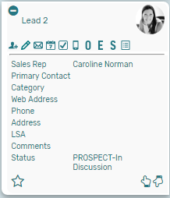**Lead: New Contact**Add a new contact to the lead from the Kanban card.
2. **Lead: New Note**Add a new note to the lead from the Kanban card.
3. **Lead: New Email**Add a new email to the lead from the Kanban card.
4. **Lead: New Event**Add a new event to the lead from the Kanban card.
5. **Lead: New Task**Add a new task to the lead from the Kanban card.
6. **Lead: New Phone Call**Add a new phone call to the lead from the Kanban card.
7. **Lead: New Opportunity**Add a new opportunity to the lead from the Kanban card.
8. **Lead: New Estimate**Add a new estimate to the lead from the Kanban card.
9. **Lead: New Sales Order**Add a new sales order to the lead from the Kanban card.
10. **Lead: Show Activity**Show a list of all activities related to the lead from the Kanban card.

### Kanban – Leads: Alternative Searches

There are three alternative searches for the *Kanban – Leads* board.

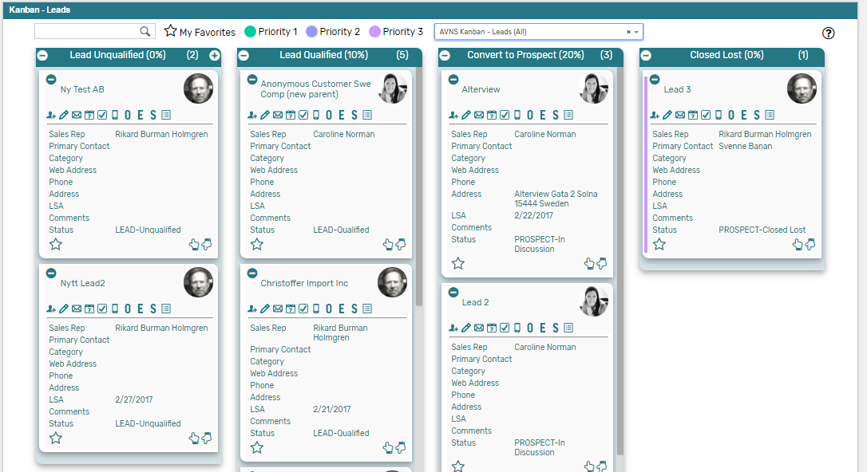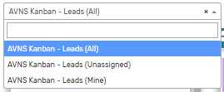

1. **AVNS Kanban Leads (All)**This search will display all registered leads in the *Kanban – Leads* board.
2. **AVNS Kanban Leads (Mine)**This search will display registered prospects where Sales Rep is *Mine* (current user) in the *Kanban – Leads* board.
3. **AVNS Kanban Leads (Unassigned)**This search will display registered prospects without an assigned Sales Rep in the *Kanban – Leads* board.

### Kanban – Leads: Available Colors

There are three colors available for the *Kanban – Leads* board, which can be used to highlight and filter the Kanban cards (*Priority 1 // Priority 2 // Priority 3*). These are defined in the *Color* subtab of the Kanban configuration record.